Wavy Open Curves
# Source: AI Source: Provided by: [Data Path: Persons Table -> ID Column: 1, Name_En Column: Motasem Essam] -> From: [ChatGPT] on [7/25/2026]
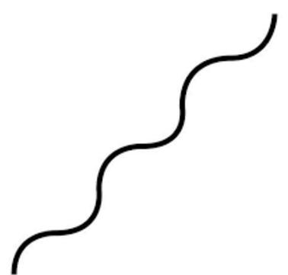
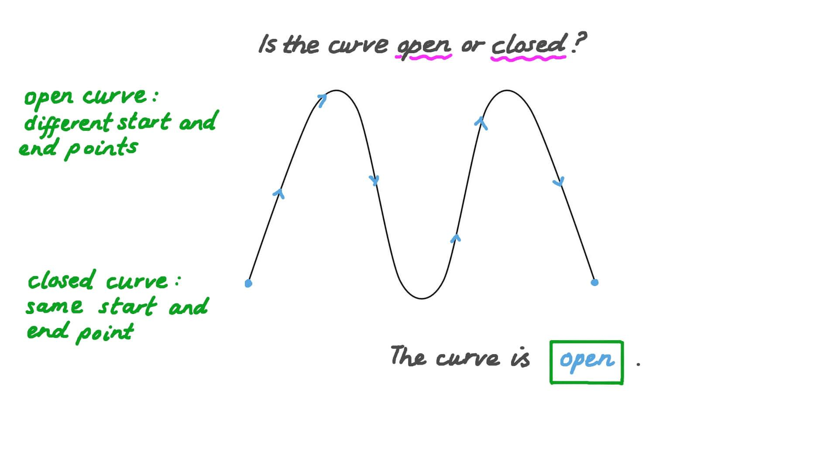
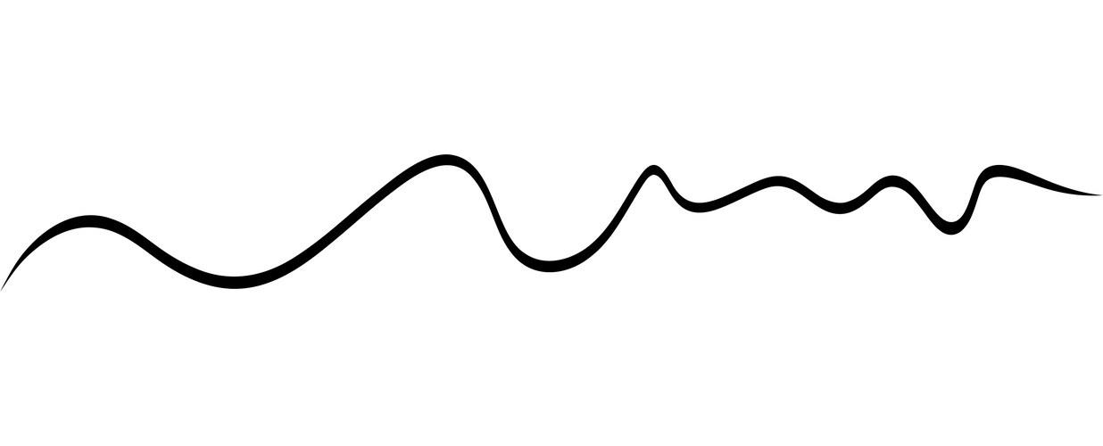
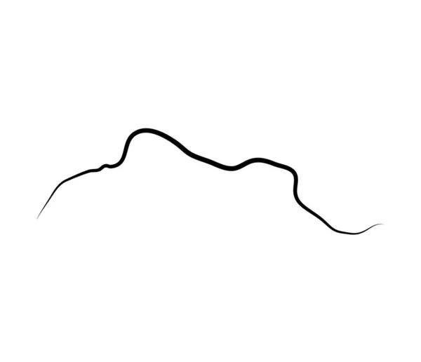

Definition
# Source: AI Source: Provided by: [Data Path: Persons Table -> ID Column: 1, Name_En Column: Motasem Essam] -> From: [ChatGPT] on [7/25/2026]
A Wavy Open Curve is an open curved shape that repeatedly changes direction, producing one or more wave-like undulations, without returning to its starting point.
$$\boxed{\text{Wavy Open Curve}=\text{Open}+\text{Curved}+\text{Repeated Undulations}}$$
Unlike a closed wavy curve, an open wavy curve has two distinct endpoints and does not enclose an area.

Characteristics
# Source: AI Source: Provided by: [Data Path: Persons Table -> ID Column: 1, Name_En Column: Motasem Essam] -> From: [ChatGPT] on [7/25/2026]
A Wavy Open Curve:
- Is open.
- Has two distinct endpoints.
- Is composed of continuous curved portions.
- Contains one or more waves or undulations.
- Repeatedly changes direction.
- Does not enclose a region.
- May have regular or irregular waves.
- May be symmetric or asymmetric.
- May have small or large amplitudes.
- May contain a varying wavelength.

Types of Wavy Open Curves

1. Regular Wavy Open Curve
# Source: AI Source: Provided by: [Data Path: Persons Table -> ID Column: 1, Name_En Column: Motasem Essam] -> From: [ChatGPT] on [7/25/2026]
A curve with approximately equal waves, amplitudes, and spacing.
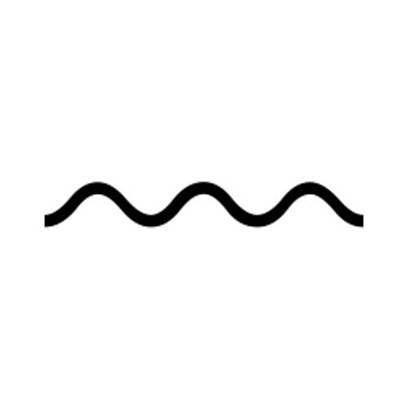
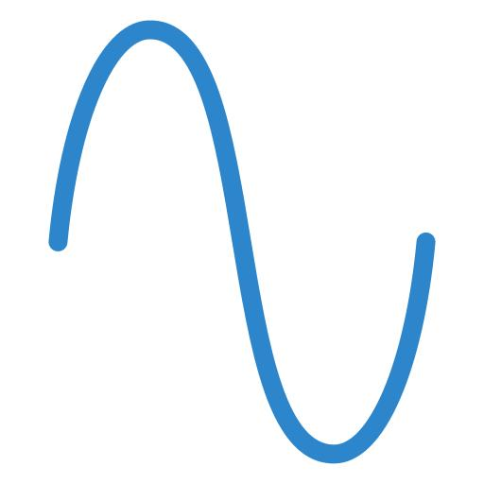
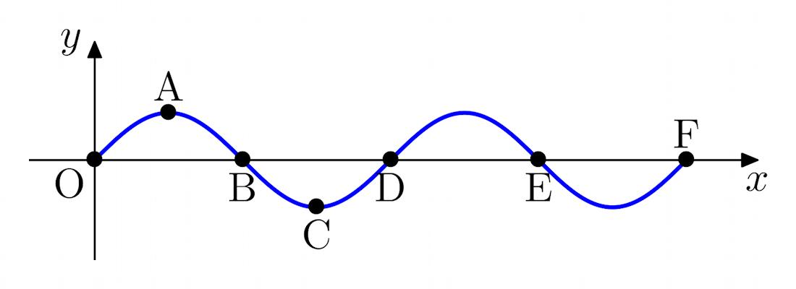
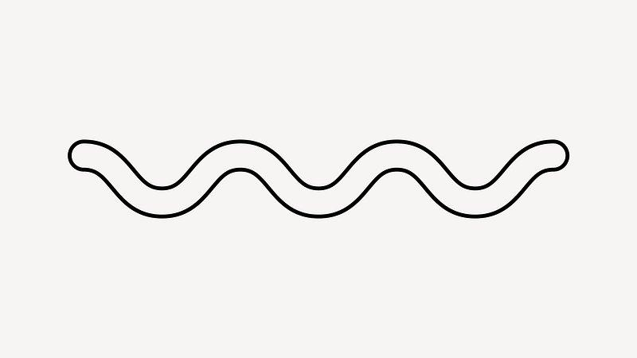
A mathematical example is a portion of:
$$y=A\sin\left(Bx+C\right)+D$$

2. Irregular Wavy Open Curve
# Source: AI Source: Provided by: [Data Path: Persons Table -> ID Column: 1, Name_En Column: Motasem Essam] -> From: [ChatGPT] on [7/25/2026]
A curve with waves of different sizes, lengths, or spacing.
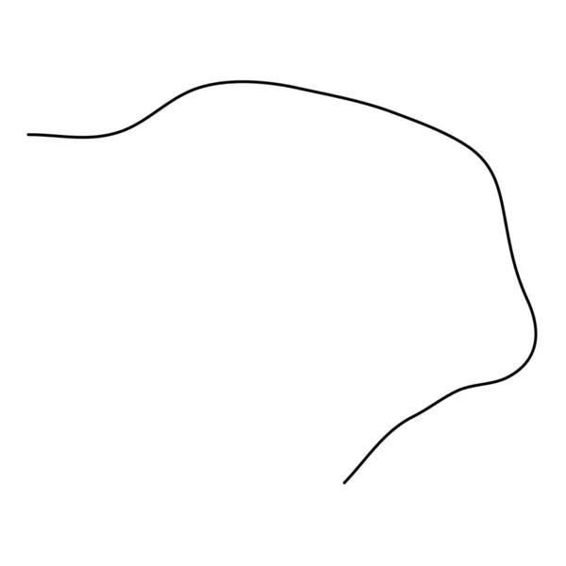
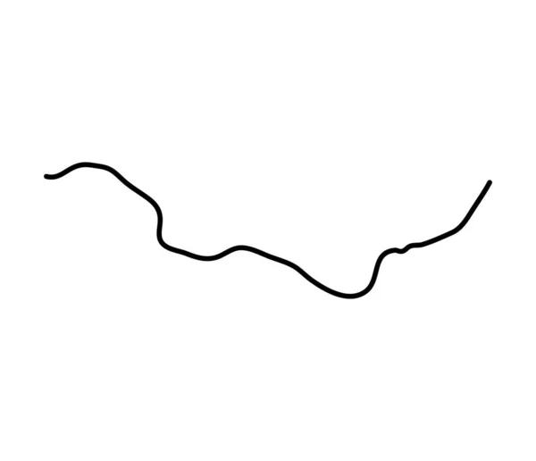
The undulations do not follow a consistent repeating pattern.

3. Smooth Wavy Open Curve
# Source: AI Source: Provided by: [Data Path: Persons Table -> ID Column: 1, Name_En Column: Motasem Essam] -> From: [ChatGPT] on [7/25/2026]
A continuously curved wave with smooth transitions between peaks and valleys.
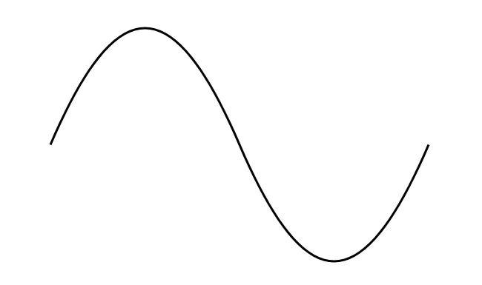
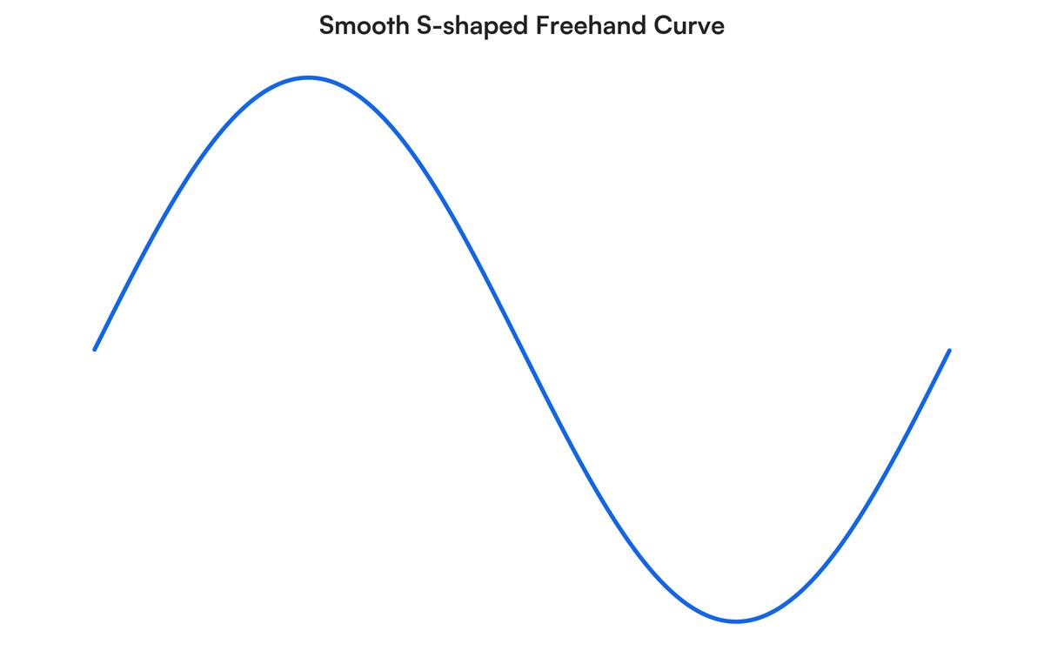
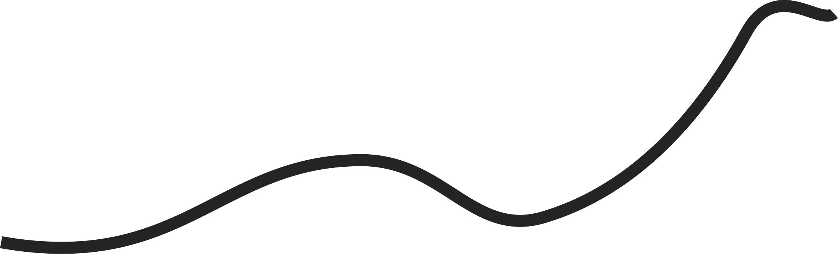
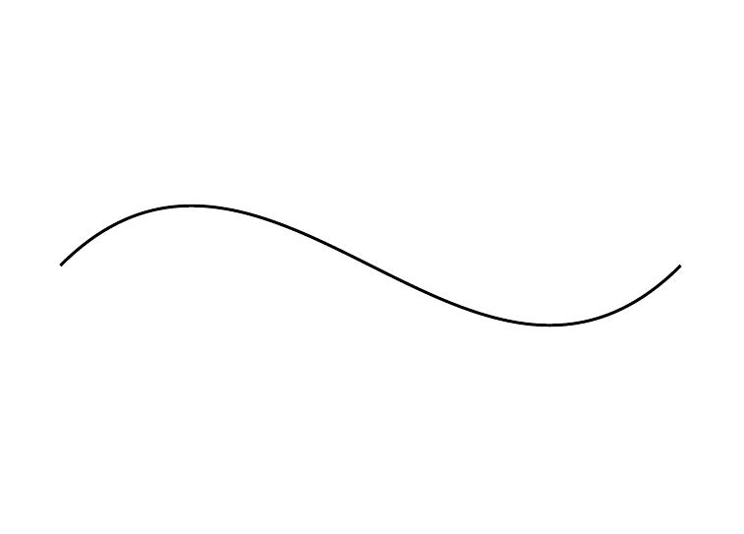
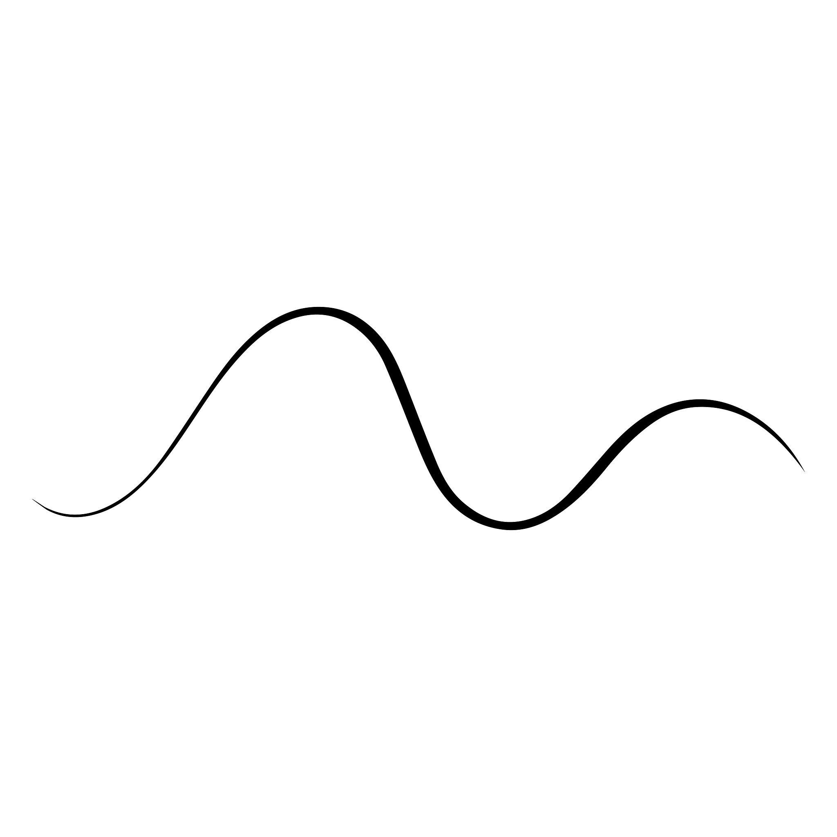
There are no sharp corners or sudden changes in direction.

4. Sharp Wavy Open Curve
# Source: AI Source: Provided by: [Data Path: Persons Table -> ID Column: 1, Name_En Column: Motasem Essam] -> From: [ChatGPT] on [7/25/2026]
A wavy open curve containing relatively sharp changes in curvature around its peaks and valleys.
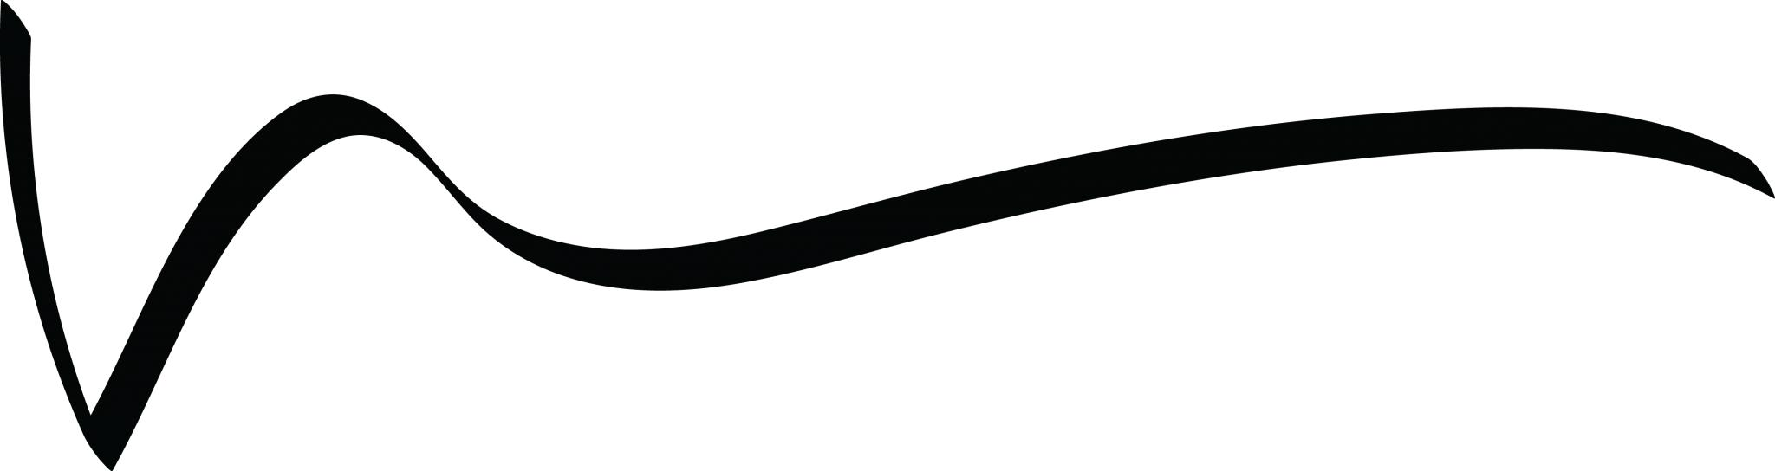
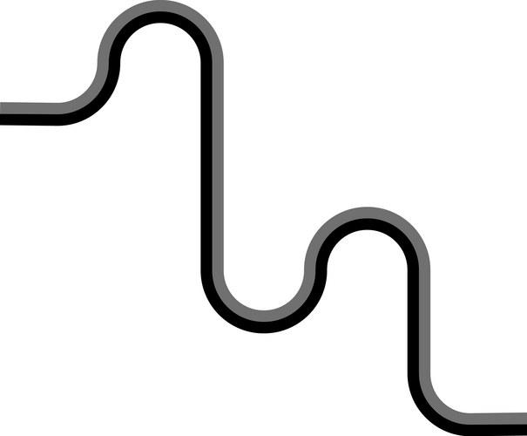
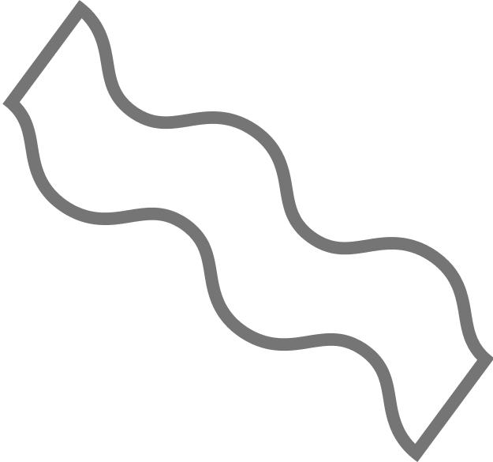
It remains curved overall but can have noticeably tighter bends.

5. Symmetric Wavy Open Curve
# Source: AI Source: Provided by: [Data Path: Persons Table -> ID Column: 1, Name_En Column: Motasem Essam] -> From: [ChatGPT] on [7/25/2026]
A wavy curve with a recognizable axis or center of symmetry.
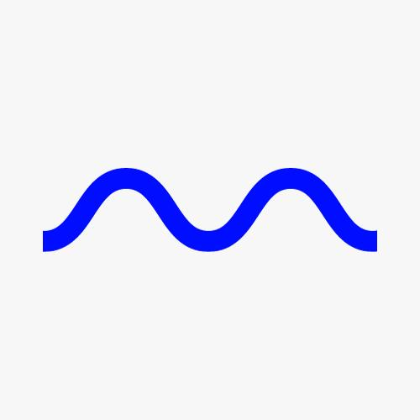
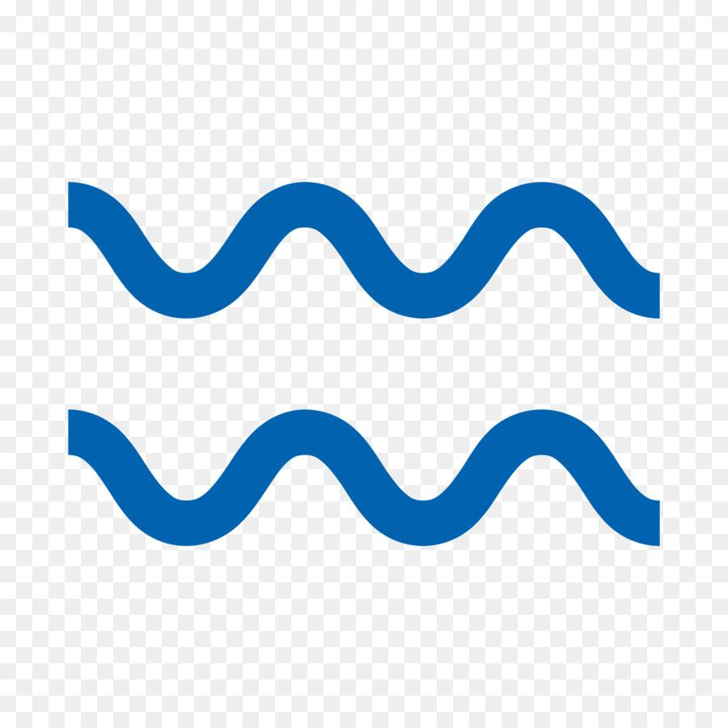
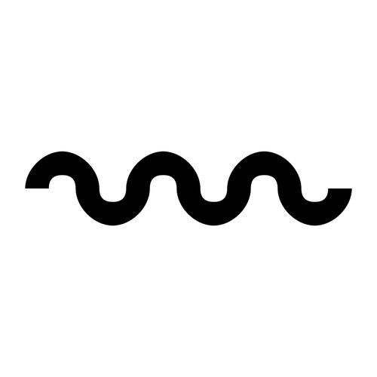
For example, the left and right portions may mirror one another.

6. Asymmetric Wavy Open Curve
# Source: AI Source: Provided by: [Data Path: Persons Table -> ID Column: 1, Name_En Column: Motasem Essam] -> From: [ChatGPT] on [7/25/2026]
A wavy curve without a regular symmetry pattern.
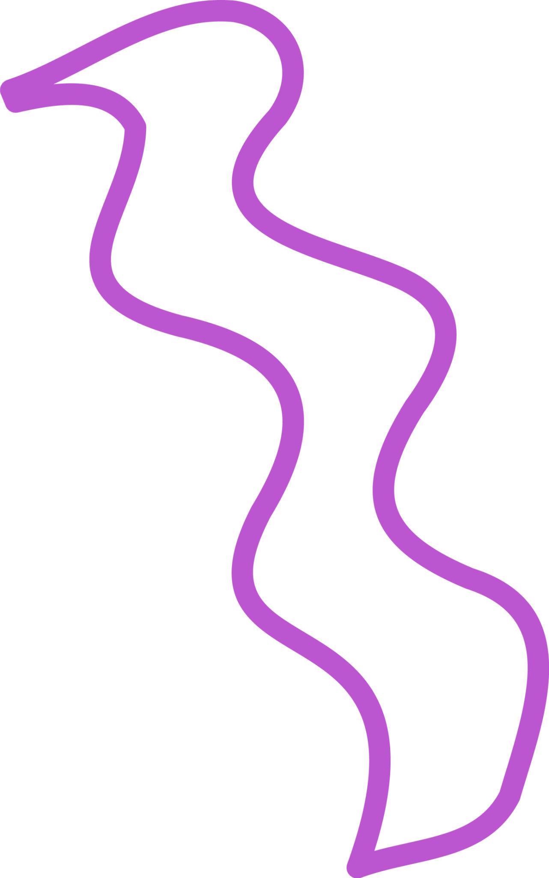
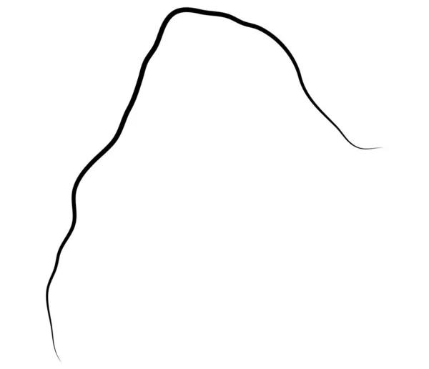
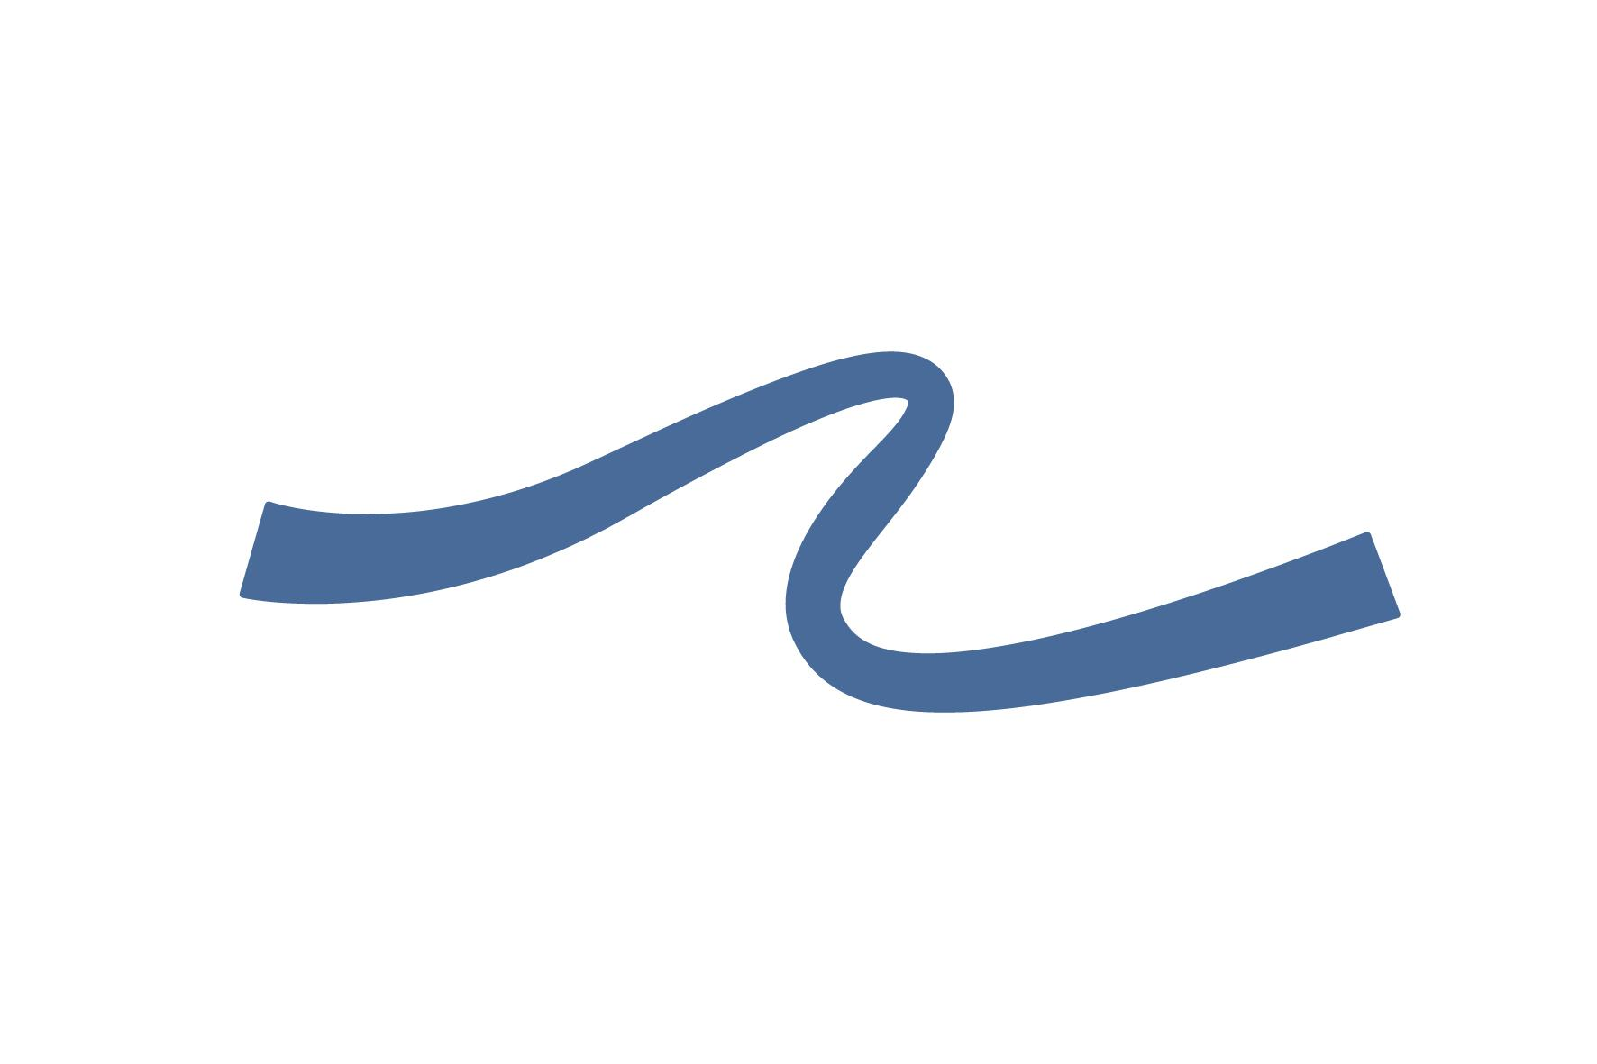
Its peaks and valleys may differ in height, width, and spacing.

7. Low-Amplitude Wavy Open Curve
# Source: AI Source: Provided by: [Data Path: Persons Table -> ID Column: 1, Name_En Column: Motasem Essam] -> From: [ChatGPT] on [7/25/2026]
A curve with shallow waves and relatively small vertical deviations.
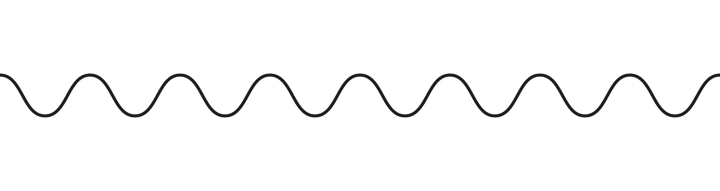
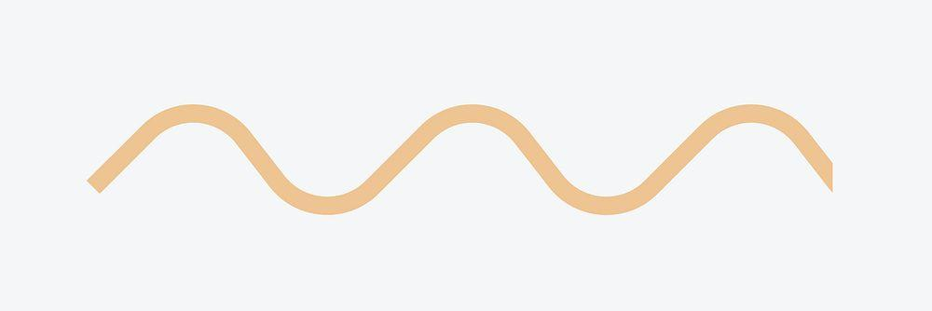
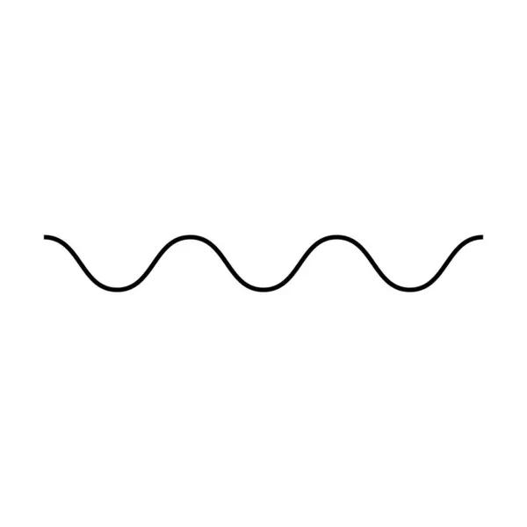
The curve remains close to its general direction.

8. High-Amplitude Wavy Open Curve
# Source: AI Source: Provided by: [Data Path: Persons Table -> ID Column: 1, Name_En Column: Motasem Essam] -> From: [ChatGPT] on [7/25/2026]
A curve with large waves and significant deviations from its general direction.
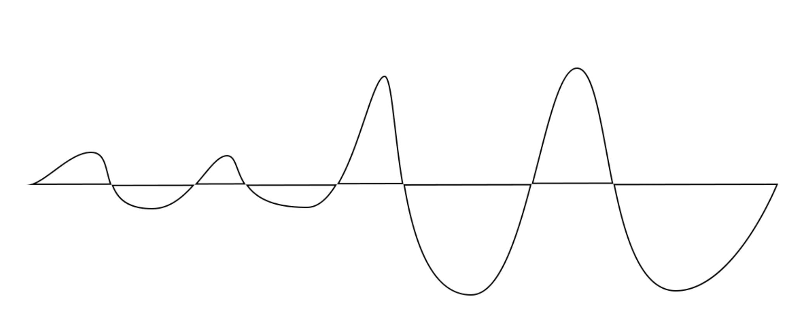
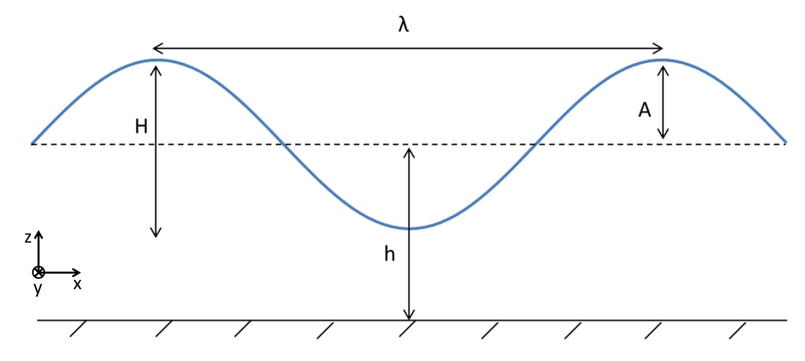
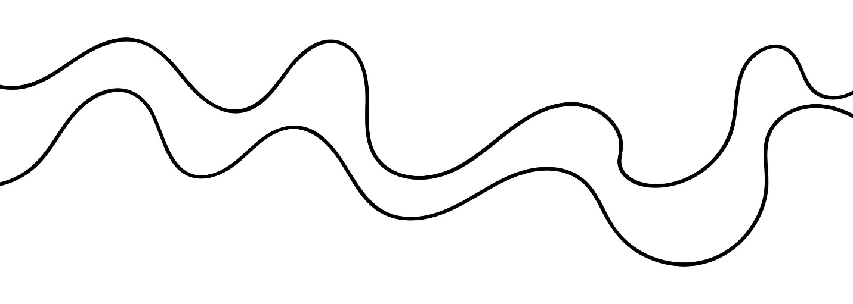
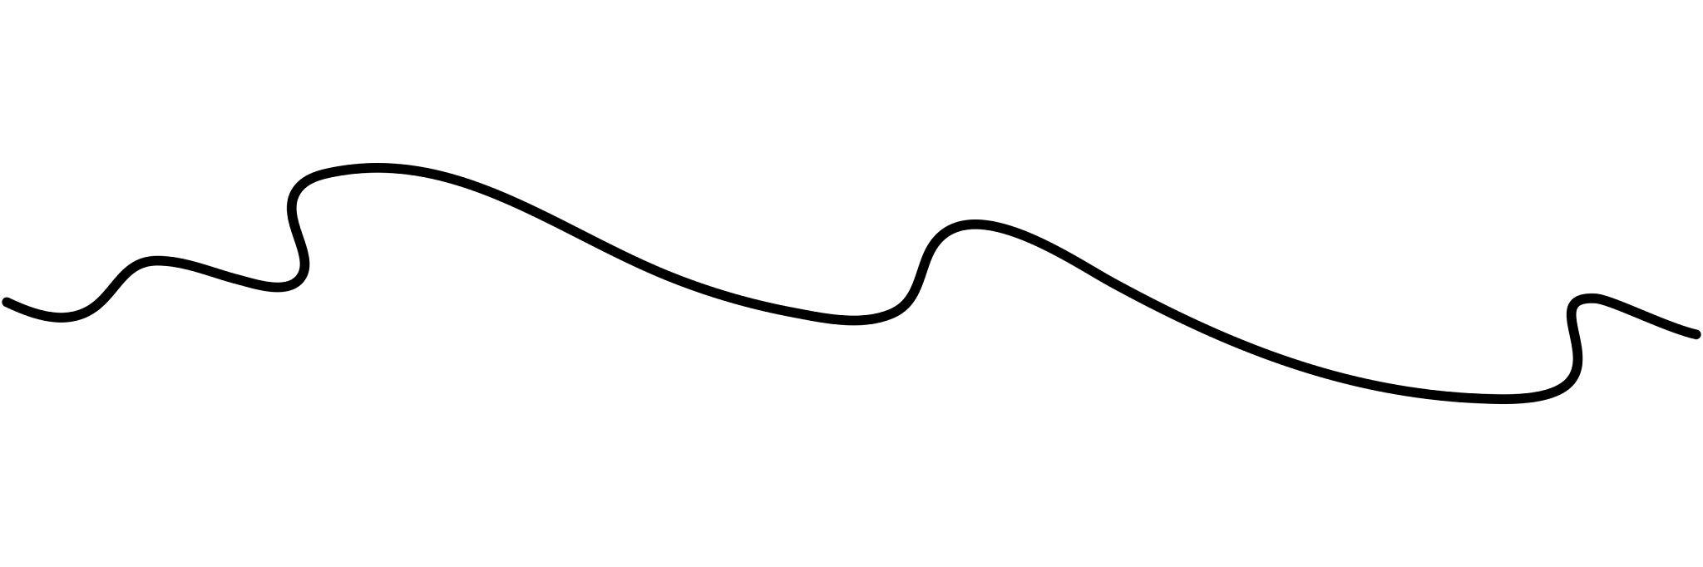
The peaks and valleys are much more pronounced.

9. Short-Wavelength Wavy Open Curve
# Source: AI Source: Provided by: [Data Path: Persons Table -> ID Column: 1, Name_En Column: Motasem Essam] -> From: [ChatGPT] on [7/25/2026]
The curve contains many waves over a relatively short distance.
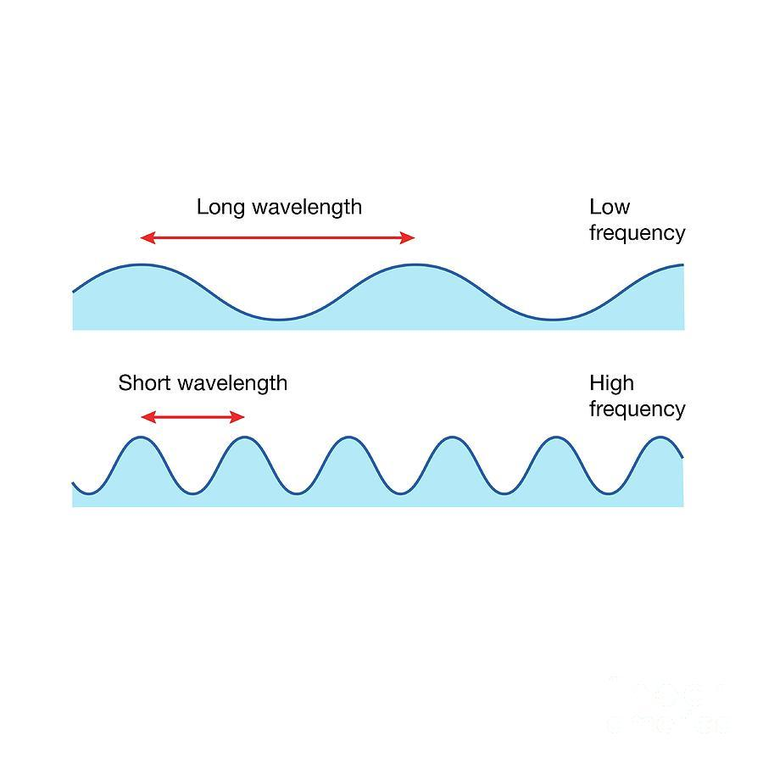
The waves are closely spaced.

10. Long-Wavelength Wavy Open Curve
# Source: AI Source: Provided by: [Data Path: Persons Table -> ID Column: 1, Name_En Column: Motasem Essam] -> From: [ChatGPT] on [7/25/2026]
The curve contains broad, widely spaced waves.
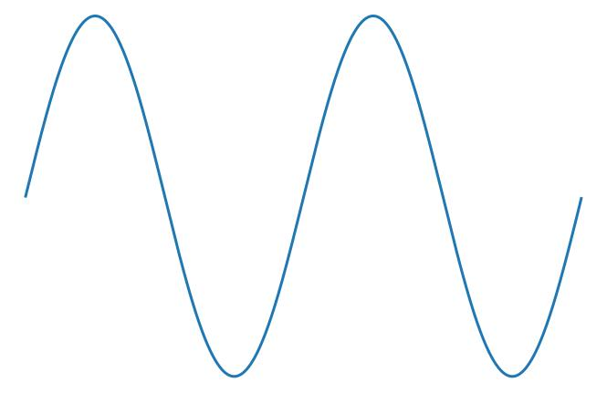
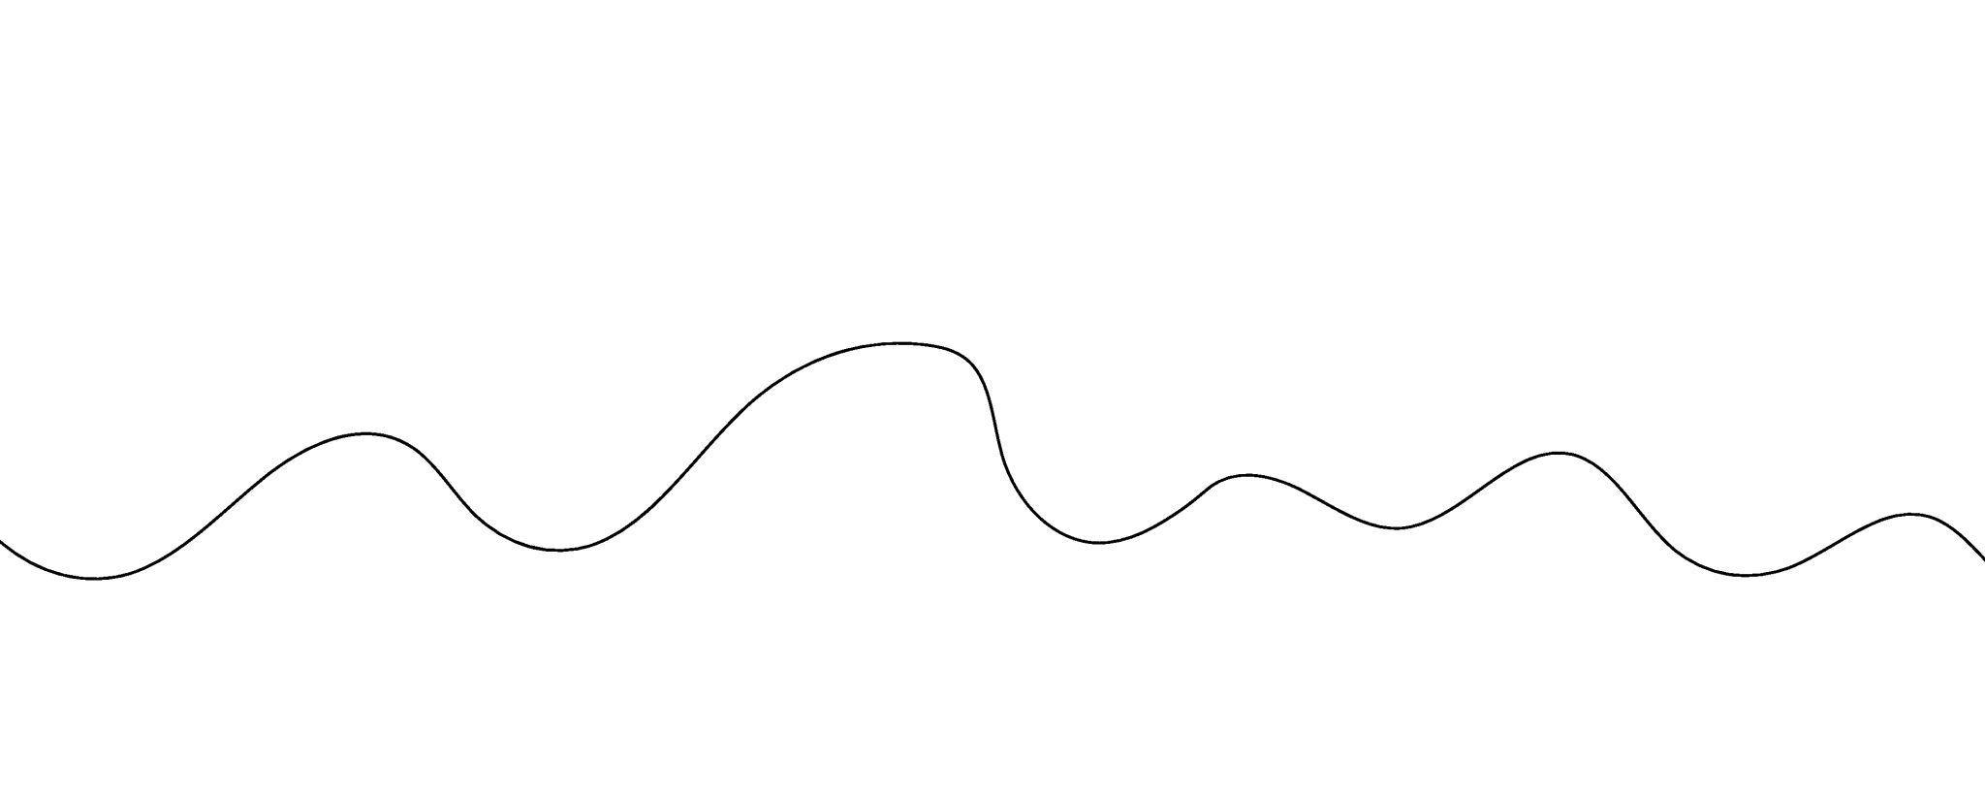
The individual undulations extend over greater distances.

11. Sinusoidal-Like Open Curve
# Source: AI Source: Provided by: [Data Path: Persons Table -> ID Column: 1, Name_En Column: Motasem Essam] -> From: [ChatGPT] on [7/25/2026]
A smooth open curve that resembles a sine or cosine wave.
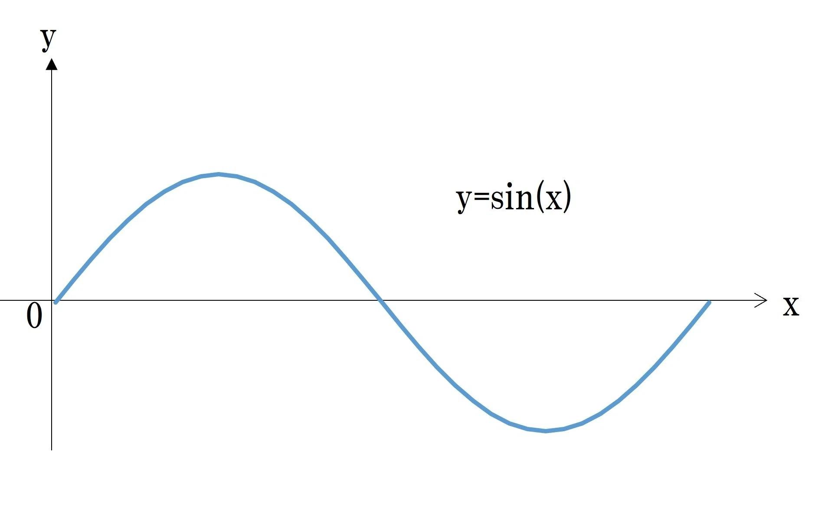
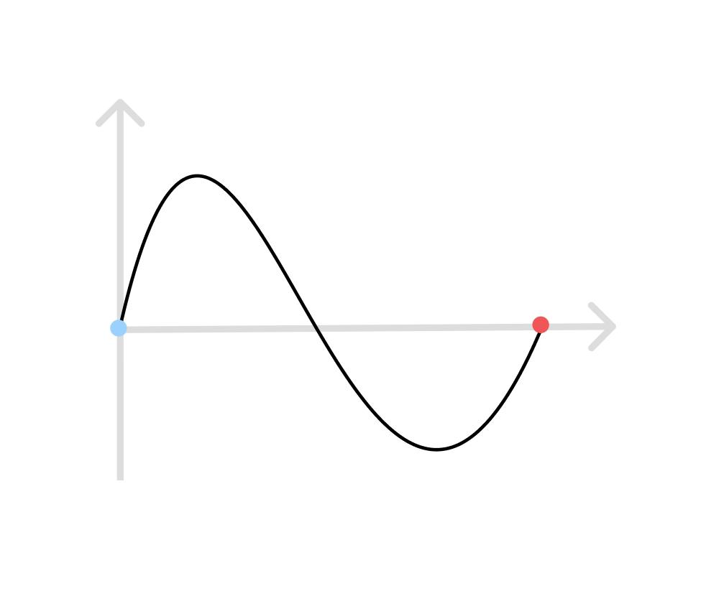
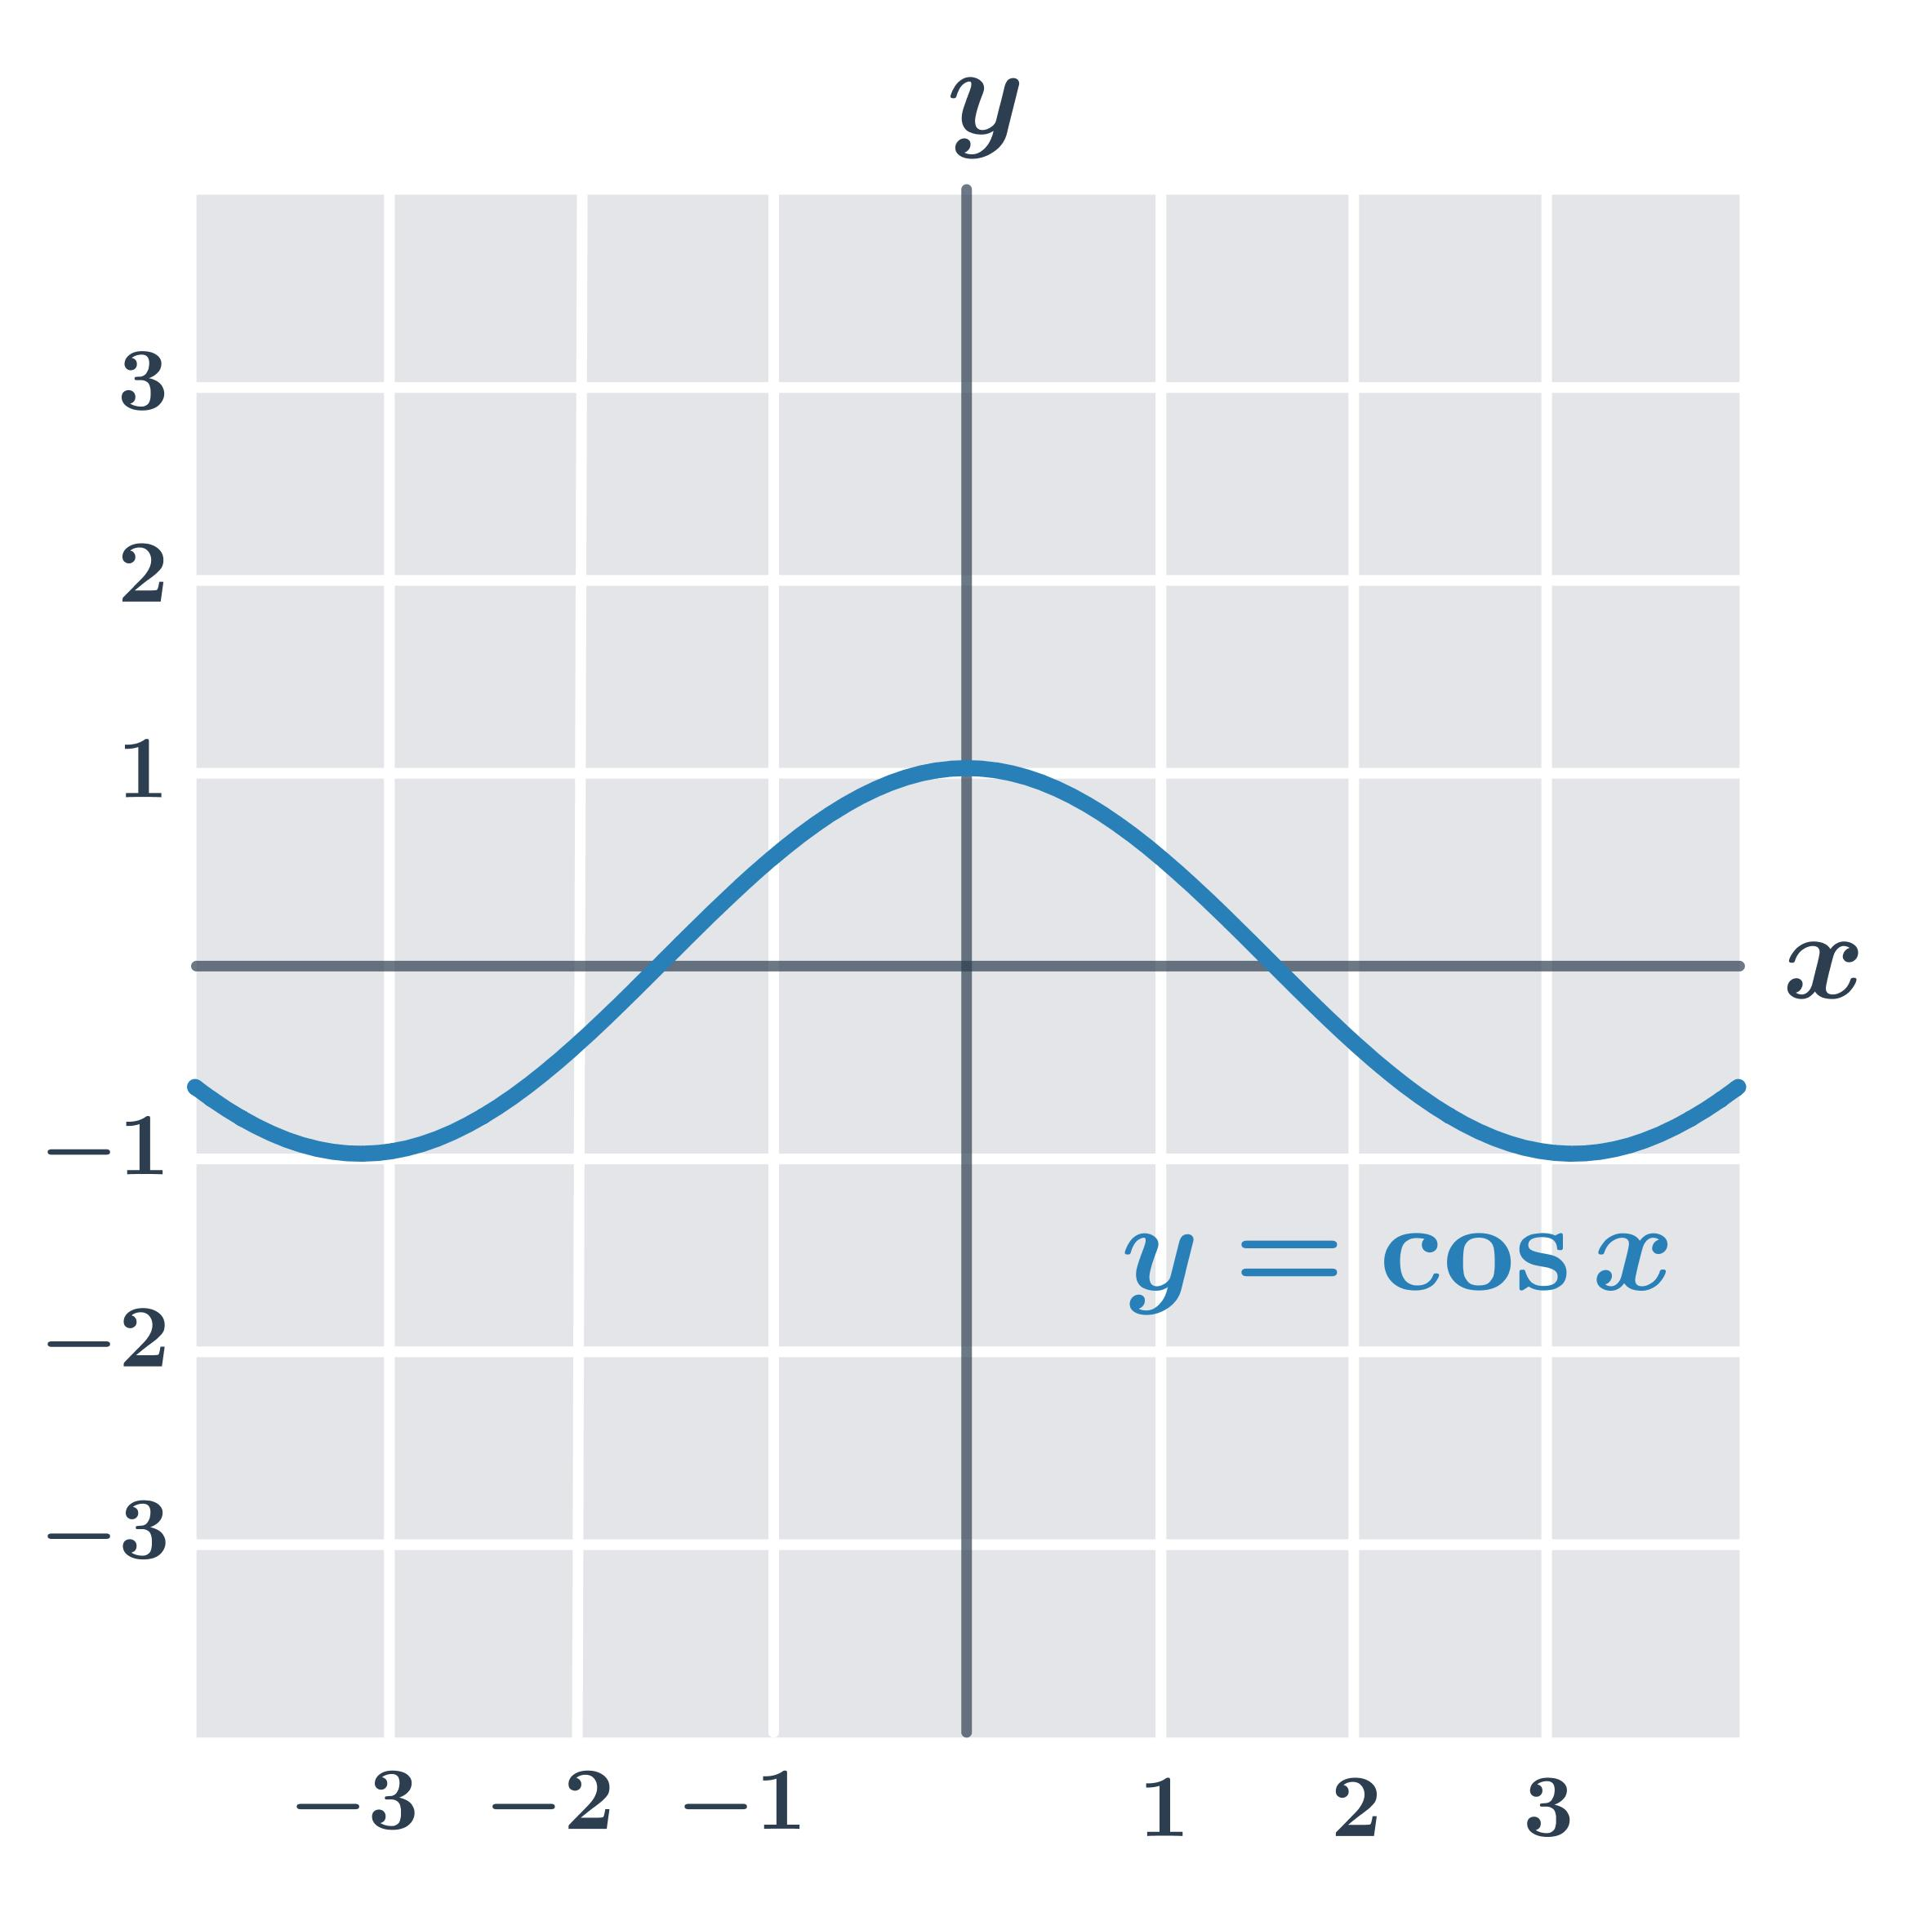
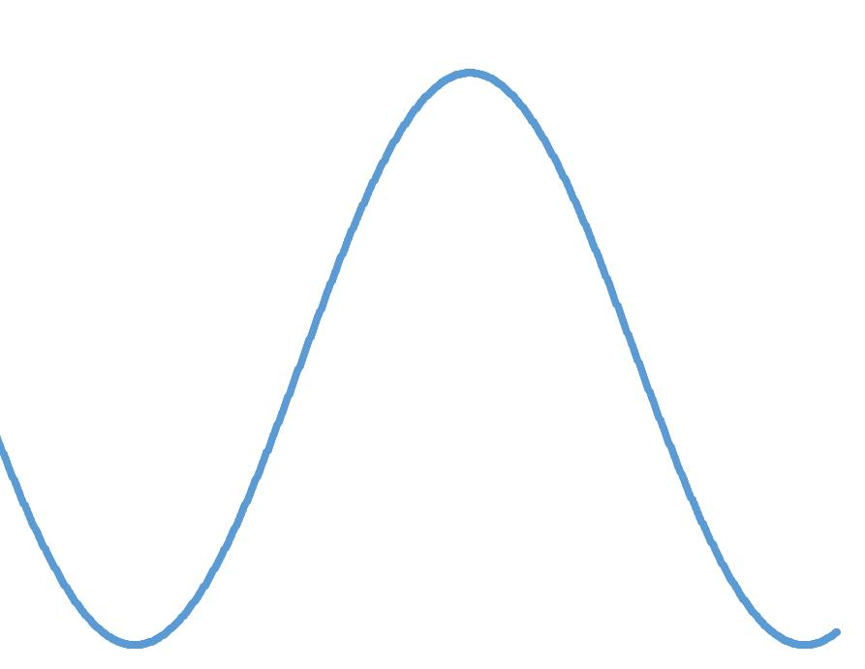
It can be represented approximately by:
$$y=A\sin\left(Bx+C\right)+D$$

12. Organic Wavy Open Curve
# Source: AI Source: Provided by: [Data Path: Persons Table -> ID Column: 1, Name_En Column: Motasem Essam] -> From: [ChatGPT] on [7/25/2026]
A naturally appearing wavy curve with smooth, irregular undulations.
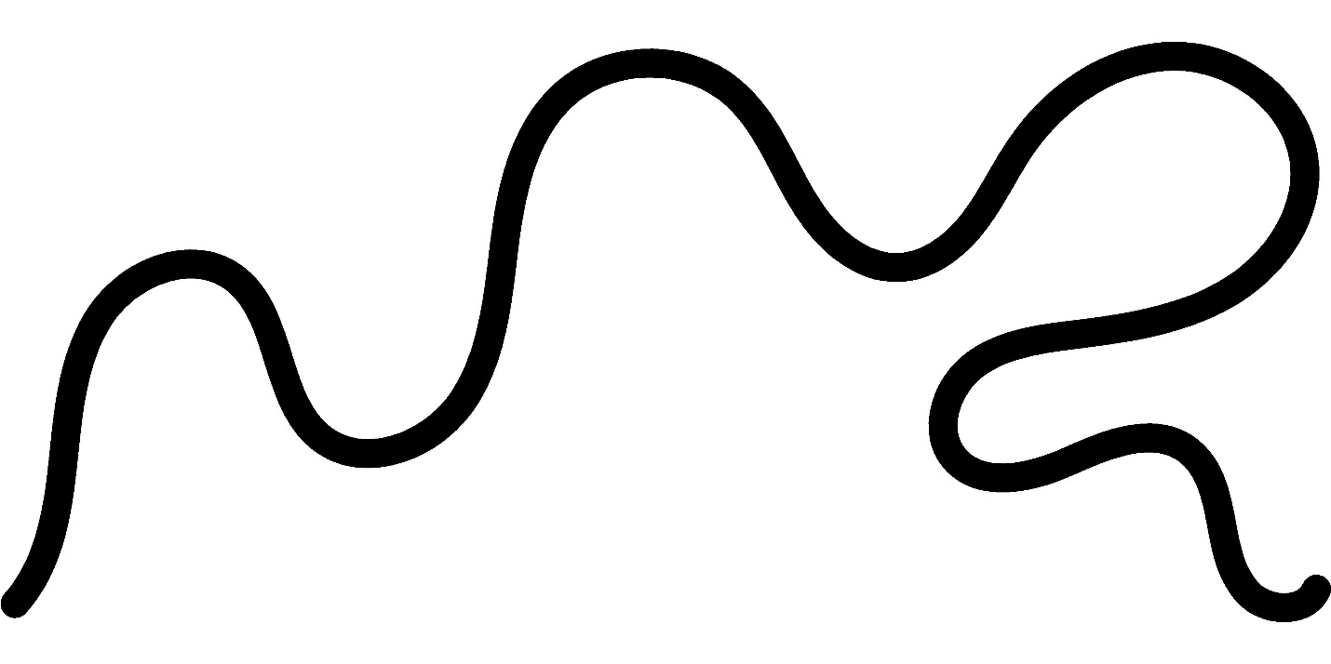
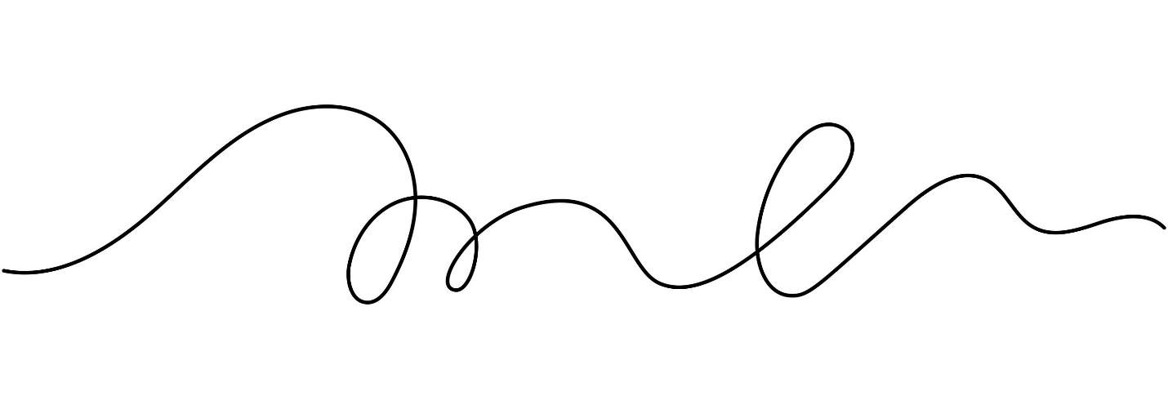
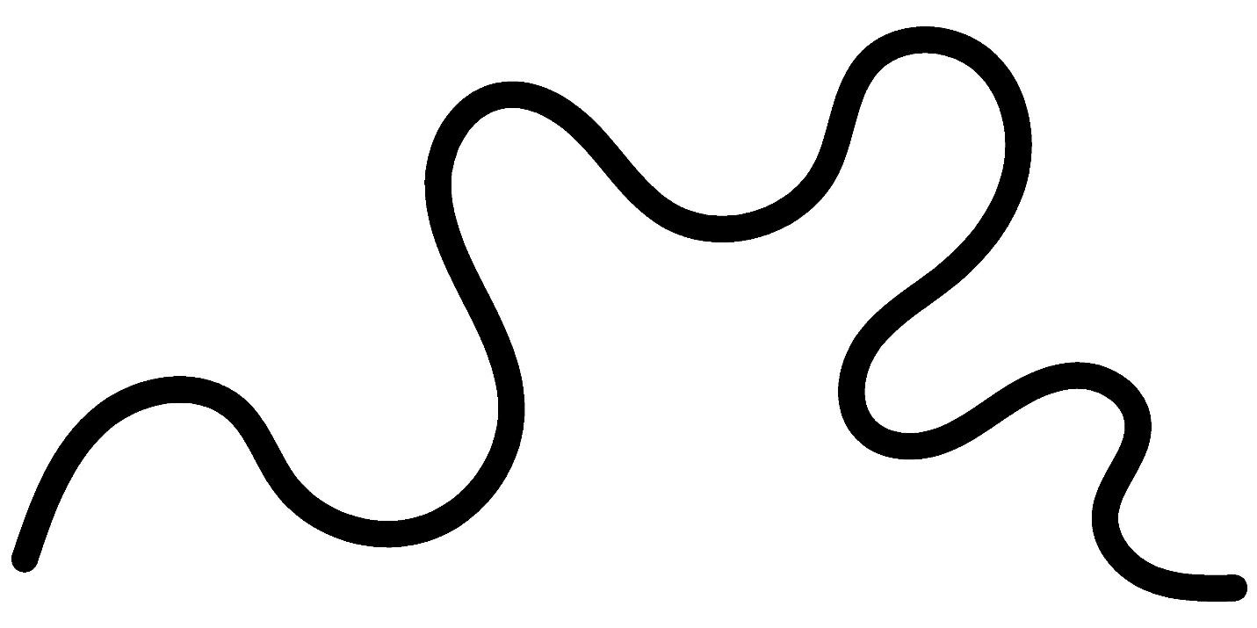
Examples can include portions of plant stems, flowing edges, or natural contours.

Wavy Open Curve vs. Spiral-Like Open Curve
# Source: AI Source: Provided by: [Data Path: Persons Table -> ID Column: 1, Name_En Column: Motasem Essam] -> From: [ChatGPT] on [7/25/2026]
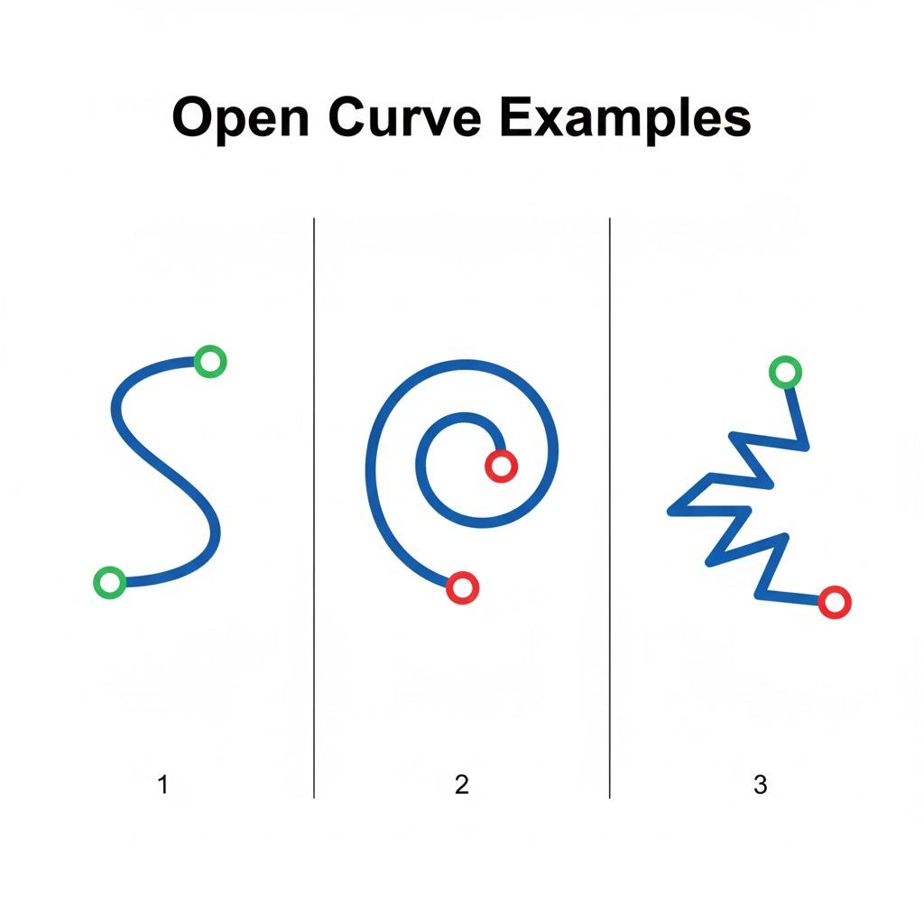
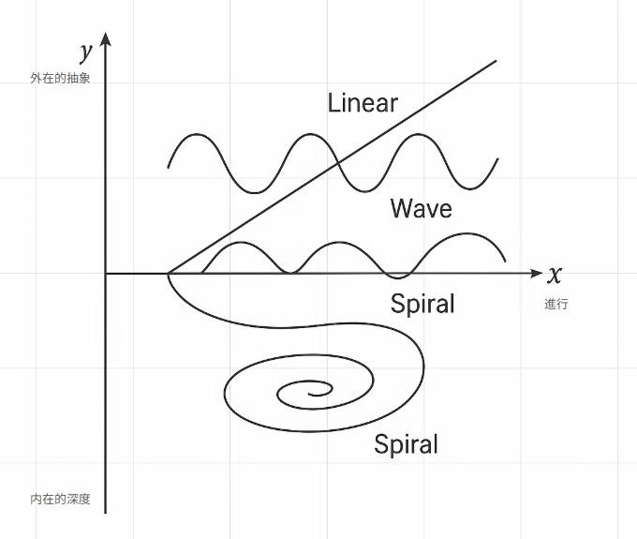
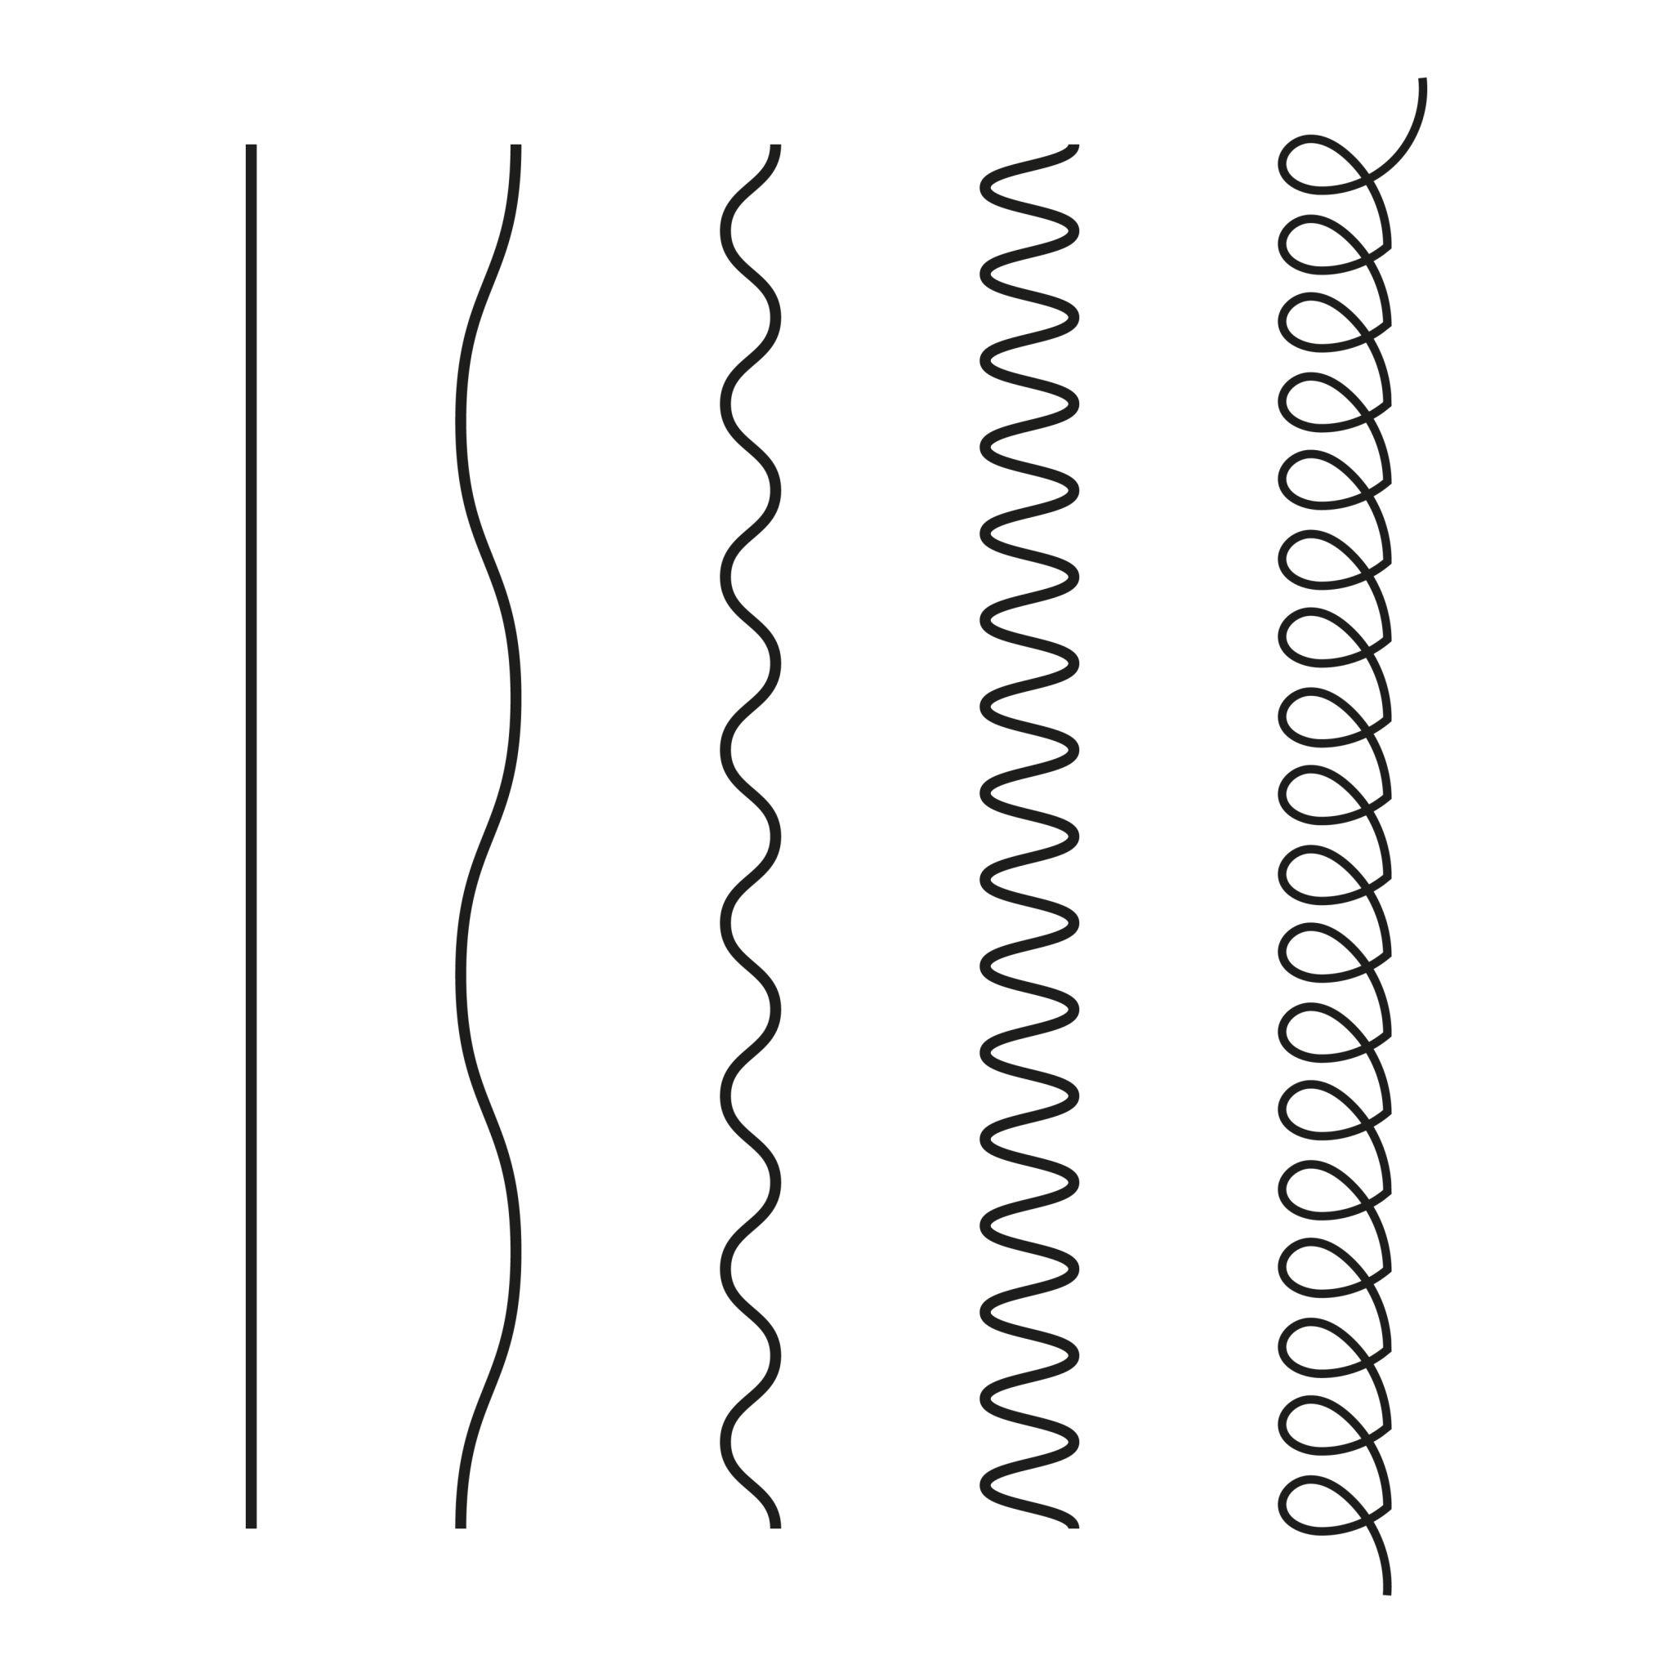
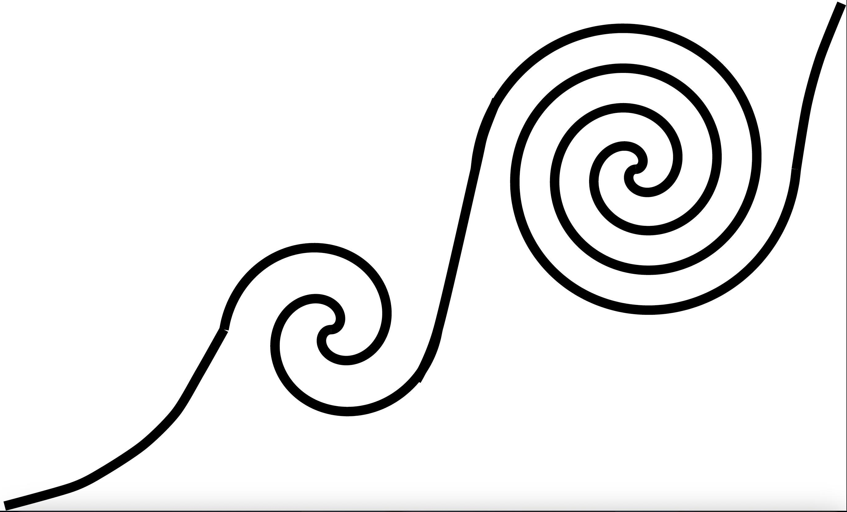
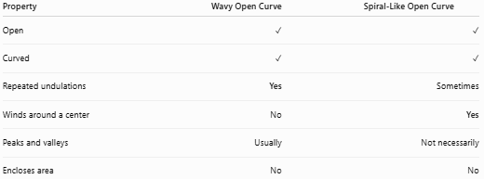
Property | Wavy Open Curve | Spiral-Like Open Curve
Open | ✓ | ✓
Curved | ✓ | ✓
Repeated undulations | Yes | Sometimes
Winds around a center | No | Yes
Peaks and valleys | Usually | Not necessarily
Encloses area | No | No
The main distinction is that a wavy curve oscillates, while a spiral-like curve winds around a center or axis.

Wavy Open Curve vs. Circular Arc
# Source: AI Source: Provided by: [Data Path: Persons Table -> ID Column: 1, Name_En Column: Motasem Essam] -> From: [ChatGPT] on [7/25/2026]
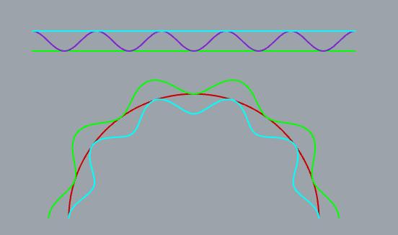
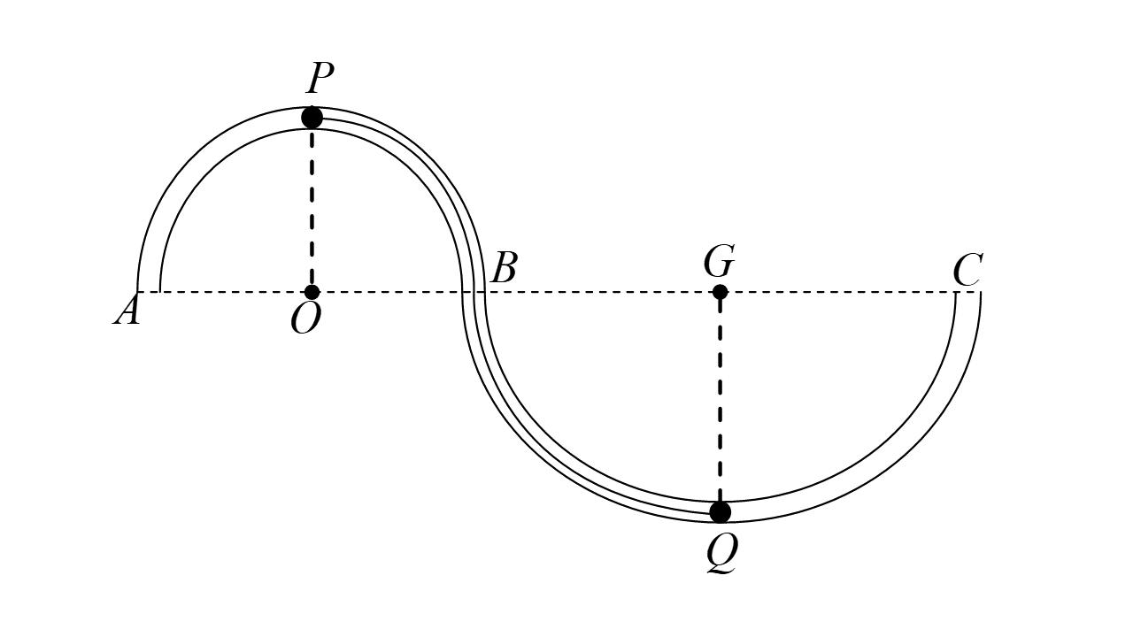
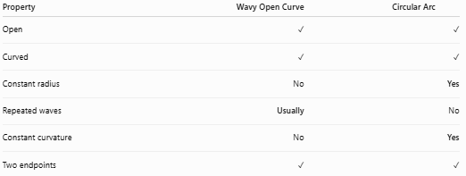
Property | Wavy Open Curve | Circular Arc
Open | ✓ | ✓
Curved | ✓ | ✓
Constant radius | No | Yes
Repeated waves | Usually | No
Constant curvature | No | Yes
Two endpoints | ✓ | ✓

Key Points
# Source: AI Source: Provided by: [Data Path: Persons Table -> ID Column: 1, Name_En Column: Motasem Essam] -> From: [ChatGPT] on [7/25/2026]
A Wavy Open Curve is:
$$\boxed{\text{Open}+\text{Curved}+\text{One or More Undulations}}$$
It:
- Has two endpoints.
- Does not close.
- Does not enclose an area.
- Contains repeated peaks, valleys, or undulations.
- Can be regular or irregular.
- Can be symmetric or asymmetric.
- Can have low or high amplitude.
- Can have short or long wavelength.
- May resemble a sine or cosine wave.
- Can also have an organic or naturally irregular appearance.
Most important distinction
$$\boxed{\text{Wavy Open Curve}=\text{Oscillating Open Curve}}$$
while:
$$\boxed{\text{Spiral-Like Open Curve}=\text{Winding Open Curve}}$$

Conclusion
# Source: AI Source: Provided by: [Data Path: Persons Table -> ID Column: 1, Name_En Column: Motasem Essam] -> From: [ChatGPT] on [7/25/2026]
Wavy Open Curves are open curved shapes characterized by repeated changes in direction that create waves, peaks, valleys, or undulations. They can be classified according to their regularity, smoothness, symmetry, amplitude, wavelength, and overall appearance.

